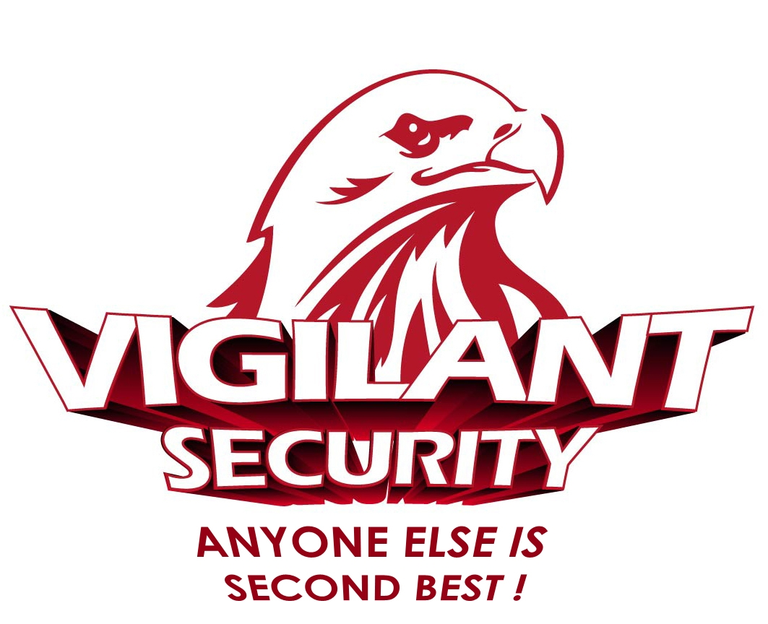
Environmental Policy
Date: 11th March 2014  Issue: 5  Review Date: 10th March 2015 | VSS-COM-POL-002
2014 OBJECTIVE - To ensure all sites work in an Environmentally effective manner and all Officers are aware of our Environmental Policy during 2014

SCOPE

Vigilant Security Services (UK) Ltd (VSS) is committed to the continual improvement of its environmental performance, with a view to reducing environmental impacts to levels not exceeding those corresponding to economically viable applications of best available practices and techniques. The purpose of this policy is to explain the Company’s Environmental Management System (EMS) and to define formal requirements, responsibilities and aims to ensure the conformity of this policy to ISO: 14001. This scope of this EMS applies to all VSS operations in the UK.

Contents

- Scope
- Normative References
- Terms and Definitions
- Environmental Management System Requirements
- Annexes
- Document History

Originator:  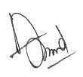 | Approved:  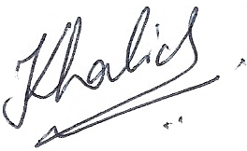
Authorised:   | Distribution: Master File 1  Company-Wide AI’s

ENVIRONMENTAL POLICY

- NORMATIVE REFERENCES

No normative references are cited.

- TERMS AND DEFINITIONS

  - Environment

Surroundings in which an organization operates, including air, water, land, natural resources, flora, fauna, humans and their interrelation.

  - Environmental Aspect

Element of an organisations activities or products or services that can interact with the environment.

  - Environmental Impact

Any change to the environment, whether adverse or beneficial, wholly or partly resulting from an organisations environmental aspect.

  - Prevention of Pollution

Use of processes, practices, techniques, services or energy to avoid, reduce or control (separately or in combination) the creation, emission or discharge of any type of pollutant or waste, in order to reduce adverse environmental aspects.

- ENVIRONMENTAL MANAGEMENT SYSTEM REQUIREMENTS

  - General Requirements

VSS shall establish, document, implement, maintain and continually improve it’s Environmental Management System (EMS) in accordance with the requirements of ISO:14001-2004 and determine how it will fulfill these requirements. The scope of our EMS is defined in Sec 1.

  - Policy Statement

Vigilant Security services Ltd (VSS) is committed to the continual improvement of its environmental performance, with a view to reducing environmental impacts to levels not exceeding those corresponding to economically viable applications of best available practices and techniques. Our policy is appropriate to the nature, scale and environmental impacts of our activities, products and services.

This policy is the driver for implementing and improving our Environmental Management System (EMS) so that we can maintain and potentially improve our environmental performance. Our Senior Management Team (SMT) is committed to ensuring that we comply with applicable legal requirements which relate to our Environmental Aspects and other requirements, to prevent pollution and to continually improve.

This policy provides the framework upon which we set and review our environmental objectives and targets. VSS shall document, implement and maintain this policy. This policy is communicated to all employees and clients in the Site Assignment Reference Manual, to ensure their awareness of both this policy and their role in implementing, maintaining and improving it.

Our environmental performance will be reviewed 4-weekly at our SMT meeting to monitor our progress and ensure our compliance, and this policy will be reviewed bi-annually or sooner if required by legislative change or a significant change in our business.

VSS shall ensure this policy is available to the public on its website www.vigilantsecurityservices.co.uk
.

4.3 Planning

4.3.1 Environmental Aspects

The Compliance consultant shall periodically review the environmental aspects of our activities, products and services within the defined scope of our EMS that we can control and those we can influence. Our procedure is to take into account planned or new developments, or new or modified activities, products and services and determines those aspects that have or can have significant impact(s) on the environment (i.e. Significant Environmental Aspects (SEAs). This review will take place at each periodic Senior Management Team (SMT) meeting where we shall review the materials and equipment we are using and assessing their effect on the environment. These SEAs are recorded in our Register of Environmental Aspects & Impacts, Annex A, complete with identified Control Measures, and ‘risk-rated’ using the following methodology:
- Impact The severity of the environmental impact.
- Scale The size or likelihood of the impact.
- Risk Rating The actual risk rating of the impact.
Both impact and scale are graded as follows:
- Low Minor
- Medium Significant
- High Major
The Risk Rating is assessed using the following Risk Matrix:

High Impact | MED | HIGH | HIGH
Medium Impact | LOW | MED | HIGH
Low Impact | LOW | LOW | MED
 | Low Scale | Med Scale | High Scale

VSS shall document this information and hold both electronically with this policy and ‘hardcopy’ in Master File 1. VSS shall ensure that the SEAs are taken into account in establishing, implementing and maintaining this EMS.
4.3.2 Legal and Other Requirements

In order for VSS to identify its applicable legal requirements and other requirements to which we subscribe related to its environmental aspects and determine how these requirements apply to its environmental aspects, we monitor various websites and subscribe to email updates from government bodies and other outside sources covering the Environmental issues.

Utilizing outside sources such as the HSE and Envirowise, we have set up this database, identifying all areas requiring our compliance and detailing how we are complying with them. This database will form our ‘Register of Legislation’, and will be taken into account when maintaining and developing our EMS.

VSS receive an emailed monthly environmental update from Envirowise.Gov. Should our register need updating, the Compliance Consultant is responsible for accessing the database and annotating details of our compliance accordingly.

The compliance Consultant will also research this database and www.netregs.gov.uk prior to updating this register, if required, and reporting any changes at each SMT. Should the scope of our business change the Business Systems Manager is responsible for ensuring our ‘on-line’ register is updated accordingly.

4.3.3 Objectives, Targets & Programme(s)

VSS shall establish, implement and maintain documented Environmental Objectives and targets, at relevant functions and levels within the organization.

The objectives and targets shall be measurable, where practicable, and consistent with this environmental policy, including the commitments to prevention of pollution, to compliance with applicable legal requirements and with other requirements to which the organization subscribes, and to continual improvement.

When establishing and reviewing its objectives and targets, VSS shall take into account the legal requirements and other requirements to which the organisation subscribes, and its significant environmental aspects. It shall also consider technological options, its financial, operational and business requirements, and the views of interested parties.

VSS shall establish, implement and maintain a programme(s) for achieving its objectives and targets. Programme(s) shall include:

- Designation of responsibility for achieving objectives and targets at relevant functions and levels of the organization.

- The means and time-frame by which they are to be achieved.

These Objectives and Targets are measurable, where practicable, and consistent with this policy, including the commitments to prevent pollution, to compliance with applicable legal requirements and with other requirements to which we subscribe, and to continual improvement.

The progress status of these Objectives and Targets will be reviewed and minuted at the 4-weekly SMT meetings taking into account the legal requirements and other requirements to which we subscribe, and our significant environmental aspects. We will also consider our technical options, operational and business requirements, and the views of other interested parties. These Objectives are detailed at Annex B and summarized at Annex C.

4.4 IMPLEMENTATION AND OPERATION

4.4.1 Resources, Roles, Responsibility and Authority

The SMT will ensure the availability of resources essential to establish, implement, maintain and improve our EMS. Resources include human resources and specialised skills, organisational infrastructure, technology and financial resources.

Roles, responsibilities and authorities shall be defined, documented and communicated in this policy in order to facilitate effective environmental management. The CM is responsible and has authority for:

- Ensuring that the EMS is established implemented and maintained in accordance with the requirements of ISO 14001.

- Reporting on the performance of the EMS for review, including recommendations for improvement at the 4-weekly SMT meetings.

Further roles and responsibilities have been defined in Section 4.3.3 and authorities will be set by the SMT as required during the 4-weekly SMT meetings.

4.4.2 Competence, Training and Awareness

VSS shall ensure that any person(s) performing tasks for it or on its behalf that have the potential to cause a significant environmental impact(s) identified by VSS is (are) competent on the basis of appropriate education, training or experience, and will retain associated records. This awareness training will consist of:

- Initial EMS awareness training by the HR Director for all new employees during their induction followed by a signed declaration on their ‘Acceptance of Employment’ letter from HR.

- Annual EMS awareness refresher training by the Business Systems Manager for all Head Office employees.

- Inclusion of this Policy in the site Assignment Instructions.

- Regular EMS awareness training completed by our Mobile supervisors’ during their site audits.

- Reference to our EMS when required in our Safety Committee minutes which are sent to all employees.
The Human Resources (HR) Director shall identify training needs associated with the Company’s environmental aspects and its EMS and provide training or take other action to meet these needs, and will retain associated records.

The HR Director shall ensure VSS employees are aware of:

- The importance of conformity with this policy and procedures and with the requirements of the EMS.

- The significant environmental aspects and related actual or potential impacts associated with their work, and the environmental benefits of improved personal performance.

- Their roles and responsibilities in achieving conformity with the requirements of the EMS and the potential consequences of departure from specified procedures.

4.4.3 Communication

The Operations Director is responsible for ensuring the effective communication of environmental information at all levels of the Company’s structure:

- Ensuring an updated copy of this policy is available to all employees on site and for all ‘Head-Office’ employees in the Master Document Files held at AMC House.

- Annual Quality Management System Training for all ‘Head-Office’ employees.

- The distribution of our bi-annual Safety Committee minutes to every employee.

- Environmental updates in the Company News Letter.

The Operations Director is responsible for receiving, documenting and responding to relevant communication from external interested parties, recording details in the HSE section of our Document Control Register.

VSS does not communicate externally about its significant environmental aspects. This decision will be reviewed by the SMT, and should we decide to communicate externally we will establish and implement a method for this external communication.

4.4.4 Documentation

Our EMS documentation shall include:

- This policy, the objectives and targets detailed in Sec 2 and the supporting documentation detailed therein.

- The description of the Scope of the EMS (Sec 1).

- The description of the main elements of the EMS and their interaction, and reference to related documents.

- Documents, including records, required by ISO:14001.

- Documents, including records, determined by the organization to be necessary to ensure the effective planning, operation and control of processes that relate to its significant environmental aspects. These will be held electronically by the Business Systems Manager and hardcopy in Master File 1 within The Foundry.

4.4.5 Control of Documents

The Operations Director is responsible for ensuring that the documents required by our EMS are controlled in accordance with our Quality Support Process VSS-COM-PRO-002. This Process details the:

- Approval of documents for adequacy prior to issue.

- Review and update as necessary and re-approval of documents.

- Identification of changes and the current revision status of documents.

- Availability at point of use of the relevant versions of applicable documents.

- Procedure for ensuring documents remain legible and readily identifiable.

- Procedure for ensuring that documents of external origin determined by the organization to be necessary for the planning and operation of the EMS are identified and their distribution controlled, and prevent the unintended use of obsolete documents and apply suitable identification to them if they are retained for any purpose.

4.4.6 Operational Control

VSS will identify and plan its operations that are associated with the identified significant environmental aspects consistent with this policy, its objectives and targets by ensuring this policy is maintained to avoid deviation from it and communicating this policy to our suppliers and contractors where appropriate.

These actual process controls of procurement are reflected in our Quality Objective and in our Financial Process, VSS-COM-PRO-004. The Financial Controller is responsible for the development and maintenance of a Company Environmental Asset Register to include a record of energy usage and ultimate disposal details of all items of a value over £100. The HR Director is responsible for maintaining a ‘Head Office’ Environmental Asset Register for all items in Control and in The Foundry.

VSS shall monitor what waste our Officers produce and how each site ‘landlord’ disposes of our waste by contacting them annually, requesting details of their waste management schemes, and recording their response in the Assignment Instruction Schedule and their respective Site file.

VSS shall monitor and record its paper purchase and recycling levels periodically and record its ‘bottled’ water usage likewise.

4.4.7 Emergency Preparedness and Response

The VSS ‘Business Continuity Plan’ (BCP) will be implemented to identify potential/actual emergency situations and accidents that can have an impact(s) on the environment and to confirm and co-ordinate Company response to such a situation. The Business Systems Manager will co-ordinate the periodic review and testing of this Plan at each SMT.

VSS shall respond to actual emergency situations and accidents and prevent or mitigate associated adverse environmental aspects.

4.5 CHECKING

4.5.1 Monitoring and Measurement

VSS shall establish, implement and maintain a procedure to monitor and measure, on a regular basis, the key characteristics of its operation that can have a significant environmental impact. This procedure shall include the documenting of information to monitor performance, applicable operational controls and conformity with the organisations environmental objectives and targets. This is the responsibility of the BSM at the periodic SMT meeting.

4.5.2 Evaluation of Compliance

Consistent with its commitment to compliance, VSS shall establish, implement and maintain a procedure for periodically evaluating compliance with applicable legal requirements and other requirements to which it subscribes.

The Operations Director is responsible for periodically evaluating Company compliance to this policy as detailed in Sec 4.3.2. This policy will be subject to a minimum of two Internal Audits each year by the Compliance Consultant who will:

- Distil the main legal requirements we need comply to and audit against these as an evaluation of legal compliance.

- Audit this policy against each clause of ISO 14001.

- Audit this policy to evidence that VSS are complying to it.

This will ensure the effective evaluation of our EMS by auditing against the specific legal requirements. The results of Internal Audits will be recorded.

4.5.3 Non-Conformity, Corrective and Preventative Action

The Operations Director is responsible for dealing with actual and potential nonconformity and for taking corrective and/or preventative action using the Company Service Defects System ensuring the following:

- Identifying and correcting nonconformity (ies) and taking action(s) to mitigate their environmental impacts.

- Investigating nonconformity (ies), determining their causes and taking actions in order to avoid their reoccurrence.

- Evaluating their need for action(s) to prevent nonconformity (ies) and implementing appropriate actions designed to avoid their occurrence.

- Recording the result of corrective action(s) taken and reviewing the effectiveness of corrective action(s) and preventative action(s) taken.

Actions taken shall be appropriate to the magnitude of the problems and the environmental impacts encountered with the EMS being amended as necessary.

4.5.4 Control of Records

The SMT minutes will form the basis for recording Company conformity to its EMS and ISO 14001 and of highlighting the results achieved. All documents will be managed in accordance with VSS-COM-PRO-002 Section 3 ‘Document Control Process’.

4.5.5 Internal Audit

The Operations Director with the assistance of the Compliance consultant is responsible for the bi-annual audit of this policy, as detailed in Sec 4.5.2, to ensure that the Company EMS conforms to ISO:14001, has been properly implemented and maintained, and reports the audit findings to the SMT.

Our Audit program shall be planned, established, implemented and maintained by the Operations Director with the assistance of the Compliance Consultant, taking into consideration the environmental importance of the operation and the results of previous audits. Our Audit procedure shall be established, implemented and maintained that address:

- The responsibilities and requirements for planning and conducting audits, reporting results and retaining associated records.

- Determining of audit criteria, scope, frequency and methods.

Our EMS Internal Audit Schedule is:

- Internal Audit -01 - Q1.

- Internal Audit-02 - Q3.

4.6 MANAGEMENT REVIEW

The SMT will review Company EMS bi-annually during the Management Review Meetings to ensure its continuing suitability, adequacy and effectiveness. Reviews shall include assessing opportunities for improvement and the need for changes to the EMS, including this policy and its environmental objectives and targets. This review will be minuted.
Input to management reviews shall include:

- Results of internal audits and evaluations of compliance with legal requirements and with other requirements to which the organisation subscribes.

- Communication(s) from external interested parties, including complaints.

- The environmental performance of the organisation.

- The extent to which objectives and targets have been met.

- Status of corrective and preventative actions.

- Follow up actions of previous management reviews.

- Changing circumstances, including developments in legal and other requirements related to its environmental aspects and recommendations for improvements.

The outputs from management reviews shall include any decisions and actions related to possible changes to environmental policy, objectives, targets and other elements of our EMS, consistent with VSS commitment to continual improvement.

- ANNEX

A - Register of Environmental Aspects & Impacts.
B - Environmental Objectives
C - Summary of Objectives

- DOCUMENT REVISION HISTORY

2nd January 2009 | Issue 1 | Initial Document
2^{6th} March 2009 | Issue 2 | Reviewed Document
23rd December 2009 | Issue 3 | Reviewed Document
7th June 2010 | Issue 4 | Job Titles change
24th August 2011 | Issue 4 | Annual Review
15th August 2012 | Issue 4 | Annual Review
15th August 2013 | Issue 5 | Annual Review

